|  |  |  |  |  |
| --- | --- | --- | --- | --- |
| Vânzări | Clienți | Produse | Comenzi | Angajati |
| vanzare_id  *(cheie primară)*  produs_id  *(cheie externă către tabela Produse)*  client_id  *(cheie externă către tabela Clienti)*  data_vanzare  cantitate  pret_unitar  created_at  updated_at | client_id *(cheie primară)*  nume_client  prenume_client  adresă  e-mail  telefon  created_at  updated_at | produs_id *(cheie primară)*  nume_produs  descriere  pret  created_at  updated_at | comanda_id  *(cheie primară)*  client_id  *(cheie externă către tabela Clienti)*  data_comanda  suma_totala  created_at  updated_at | angajat_id  *(cheie primară)*  nume_angajat  prenume_angajat  functie  salariu  created_at  updated_at |

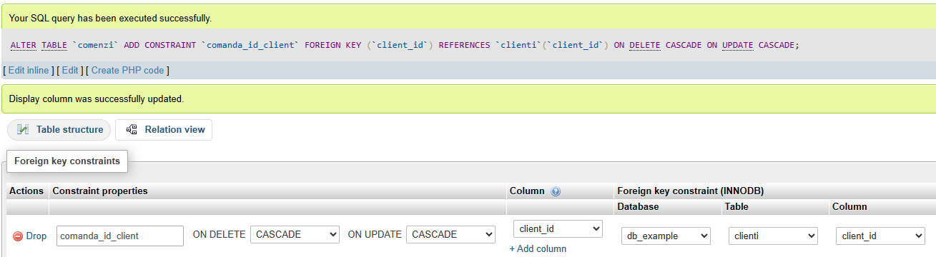

|  |  |  |  |  |
| --- | --- | --- | --- | --- |
| Administratie | Profesori | Elevi | Admitere | Discipline |
| angajat_id  *(cheie primară)*  nume  prenume  email  telefon  created_at  updated_at | profesor_id *(cheie primară)*  nume  prenume  specializare  email  telefon  created_at  updated_at | elev_id *(cheie primară)*  nume  prenume  clasa  email  telefon  created_at  updated_at | aplicare_id  *(cheie primară)*  elev_id  *(cheie externă către tabela Elevi)*  data_aplicare  stare  created_at  updated_at | disciplina_id  *(cheie primară)*  nume_disciplina  descriere  profesor_id  *(cheie externă către tabela Profesori)*  elev_id  *(cheie externă către tabela Elevi)*  created_at  updated_at |



